**273/1**

**GEOGRAPHY**

Paper 1

Jul/Aug 2019

2 ½ Hours



**MUKONO EXAMINATION COUNCIL**

**Uganda Certificate of Education**

**GEOGRAPHY**

Paper 1

2 Hours 30 Minutes

**INSTRUCTIONS TO CANDIDATES**

* *This paper consists of part* ***I*** *and* ***II***
* *Part* ***I*** *and section* ***A*** *of part* ***II*** *are compulsory*
* *Answer only* ***one*** *question from section* ***B*** *of part* ***II.***
* *Any additional question(s) attempted will not be marked.*

**PART 1**

**OBJECTIVE – TYPE QUESTIONS (30 MARKS)**

1. Fish farming in cages is mostly practiced in lake ..............................................................

A. Turkana B. Edward

C. Victoria D. Albert

1. Which of the following features is found in limestone areas of East Africa?

A. Stalactites B. Eskers

C. Levees D. Graben

1. Which of the following set of rivers was affected by drainage reversal in East Africa?

A. Kafu, Tana, Rufigi B. Pangani, Rufigi, Ruvuma

C. Kagera, Ruvuma, Rufigi D. Katonga, Kagera, Kafu

1. Cols and saddles are low lands between

A. Mountains B. hills

C. escarpments D. islands

1. .....................are mostly hindering settlement in Bududa and Kasese districts.

A. floods B. landslides

C. thunder D. earthquakes

1. The cash crop which is mainly affecting food production in the districts of Busoga region is.................

A. coffee B. sugar cane

C. cotton D. tea

1. Margherita on mountain Rwenzori is an example of a ..................................................

A. tarn B. glacial trough

C. cirque D. pyramidal peak

1. The following are examples of subsistence farming except.............................................

A. shifting cultivation B. bush fallowing

C. nomadic pastoralism D. estate farming

1. Which of the following is not a tropical disease affecting animals in East Africa?

A. trypanasomiasis B. east coast fever

C. ticks D. foot and mouth disease.

1. The largest sugarcane plantation in Uganda is known as .........................................

A. Kinyara sugarcane estate B. Lugazi sugarcane estate

C. Kakira sugar cane plantation D. Mayuge sugarcane plantation.

1. Which of the following are not fresh water fishing methods in East Africa?

A. drifting and seining B. gill-netting and use of traps

C. gill-netting and use of spears D. basket fishing and use of traps.

1. Isimba hydro-electric power station is found on river .........................................

A. Nile B. Rufigi

C. Tana D. Ruvuma

1. Bujuku valley on the Rwenzori mountain slope is an example of a .............................

A. glacial trough B. rift valley

C. hanging valley D. depression

]

1. The drainage pattern where rivers converge into the same basin is known as ...........................

A. radial B. centripetal

C. trellis D. dendritic

1. The following are characteristics of the Savanna vegetation except..............................

A. grass is tall B. trees are deciduous

C. trees have buttress roots D. trees have hard wood.

1. The major mineral exported by Tanzania is ........................................

A. coal B. gold

C. copper D. diamond

1. Which of the following industries is labour intensive.................................

A. tea processing B. grain milling

C. tourism D. sugar refining

1. The method of mining used for exploiting crude oil in East Africa is ................................

A. drilling B. open cast

C. placer method D. dredging

1. Secondary faulting within the East African Rift valley led to the formation of the .......................

A. escarpment B. graben

C. basin D. plateau.

1. Which of the following processes of weathering is not facilitated by heavy rainfall in East Africa?

A. hydrolysis B. oxidation

C. carbonation D. exfoliation

1. Lines drawn joining places having equal average cloud cover over certain period are..................

A. isohels B. Isonephs

C. Isobars D. contours

1. The type of climate experienced in Ankole-Masaka corridor is ..............................................

A. desert B. montane

C. semi- desert D. savanna

1. When condensation of the water vapour takes place at ground level it leads to the formation of .......................................

A. mist and fog B. humidity

C. hailstones D. snow.

1. The vegetation type on Mt. Kilimanjaro between the tropical rainforest and mountain health and moorland is ...........................................................

A. Bamboo forests B. Savanna vegetation

C. Equatorial forests D. Montane vegetation

1. Traces of oil have been found on the shores of lake .................................................

A. Victoria B. George

C. Albert D. Edward

1. The meeting zone for the North East and South East trade winds is called...............................

A. Inter-trade convergence zone B. Inter tropical convergence zone

C. Inter-territorial convergence zone D. None of the above.

1. Which of the following is an igneous rock?

A. limestone B. pumice

C. shale D. Quartz

1. Railway transport in East Africa is preferred because it is .................................................

A. flexible B. reliable

C. cheap D. fast

1. Which one of the following towns in East Africa developed due to the presence of mineral deposits?

A. Dodoma B. Marsabit

C. Mwadui D. Jinja

1. Doho irrigation scheme is located on river..............................................

A. Ahero B. Mobuku

C. Nile D. Manafwa

**PART II**

**MAPWORK, PHOTOGRAPH INTERPRETATION, FIELDWORK AND EAST AFRICA**

*Answer* ***four*** *questions from part II including questions 1, 2 and 3 which are compulsory.*

**SECTION A**

**1. COMPULSORY QUESTION: MAPWORK (20 MARKS)**

*Answer* ***all*** *parts of this question.*

Study the east Africa 1:50,000 (UGANDA) ALOI map extract, part of sheet 33/1 series Y732, Edition 1- U.S.D and answer the questions that follow;

a) (i) Name the man- made feature found at grid reference 224595. ***(01 mark)***

(ii) State the grid reference of the dam on river Oruk. ***(01 mark)***

b) Determine the direction of the Air photo principal point with sortie No 47 from Aloi primary

trigonometrical station (grid ref. 219506) ***(02 marks)***

c) Draw a sketch map of Aloi from Eastings 10 to 20, and Northings 50 to 60 and on it mark and

name;

(i) Rivers; Kai and Aloi

(ii) loose surface roads

(iii) Bridge on river Kai

(iv) County boundary

(v) Any two boreholes

***(08 marks)***

d) Describe the;

(i) relief of the area, ***(04 marks)***

(ii) relationship between relief and communication. ***(04 marks)***

**2. COMPULSORY PHOTOGRAPH INTERPRETATION QUESTION. *(15 MARKS)***

*Answer* ***all*** *parts of this question*

Study the photograph provided below and answer the questions that follow.

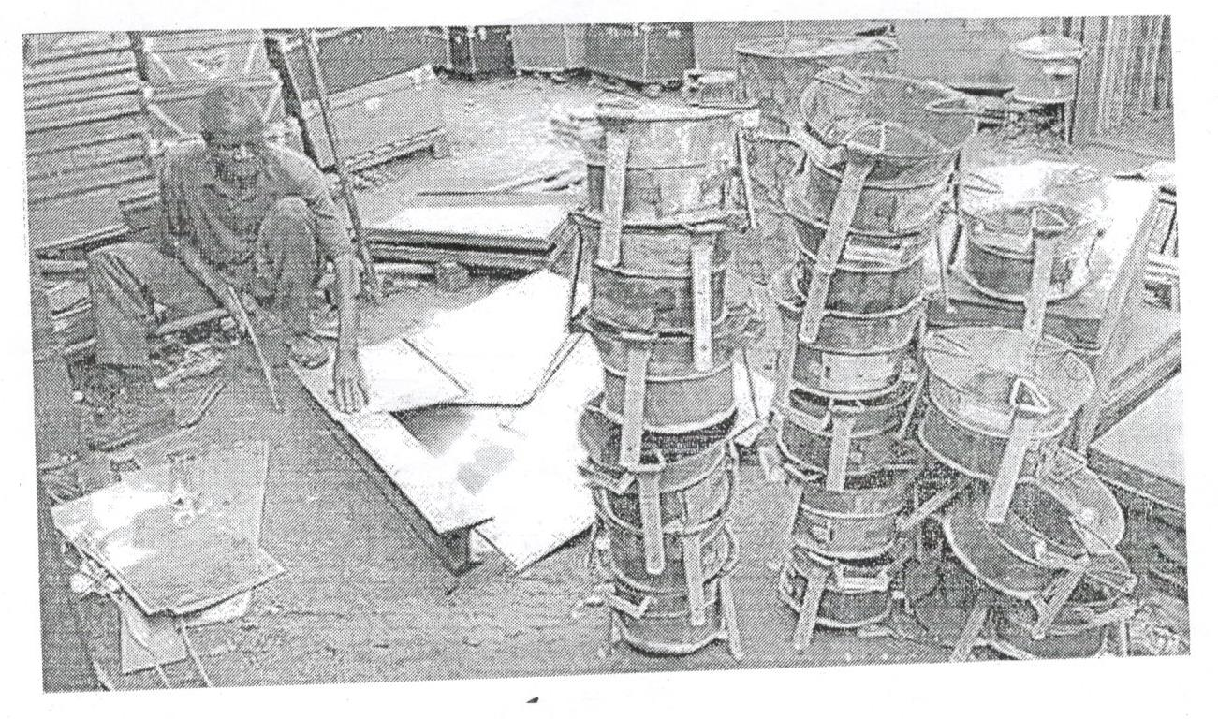

a) (i) Identify the activity taking place in the photograph. ***(01 mark)***

(ii) Mention two;

* Products being made
* Tools used to make the products identified above.

***(04 marks)***

b) Describe the factors favouring the activity taking place in the photograph. ***(05 marks)***

c) Outline the problems facing the activity taking place in the photograph. ***(03 marks)***

d) Giving a reason, suggest an area in East Africa where the photograph could have been taken.

***(02 marks)***

**3. COMPULSORY FIELDWORK QUESTION *(15 MARKS)***

*Answer* ***all*** *parts of this question.*

For any one fieldwork study you have conducted;

a) State the:

(i) topic ***(02 marks)***

(ii) objectives of the study. ***(02 marks)***

b) Draw a cross-section of the area studied and on it, mark and name the;

(i) physical features

(ii) man-made features

***(05 marks)***

c) Explain the relationship between relief and land use types in the area studied. ***(03 marks)***

d) Mention the follow-up activities that you carried out after the field study. ***(03 marks)***

**SECTION B (20 MARKS)**

**EAST AFRICA**

*Answer only* ***one*** *question from this section.*

4. a) Draw a sketch map of East Africa and on it, mark and name;

(i) Mountains; Moroto and Kenya

(ii) Lakes; Rukwa and Magadi

(iii) Rivers; Galana and Ruvuma

(iv) Kigoma port.

***(08 marks)***

b) Explain the contribution of lakes and rivers to man in East Africa. ***(05 marks)***

c) Outline the problems limiting the use of water transport in East Africa. ***(04 marks)***

d) Suggest the possible solutions that should be taken to solve the problems in (c) above.

***(03 marks)***

5. Study the climate statistics of station A in East Africa and answer the questions that follow;

**Station A: (Altitude 1112 metres)**

|  |  |  |  |  |  |  |  |  |  |  |  |  |
| --- | --- | --- | --- | --- | --- | --- | --- | --- | --- | --- | --- | --- |
| Month | J | F | M | A | M | J | J | A | S | O | N | D |
| Temp(°C) | 24 | 25 | 24 | 23 | 23 | 22 | 21 | 22 | 22 | 22 | 22 | 23 |
| Rainfall (mm) | 10 | 51 | 89 | 170 | 211 | 145 | 155 | 216 | 170 | 160 | 96 | 43 |

Adapted: Hickman, Glagys: Lands and peoples of East Africa P.33.

a) Draw a line graph to represent temperature at station A. ***(08 marks)***

b) Calculate the;

(i) Mean annual temperature ***(02 marks)***

(ii) Mean annual rainfall ***(02 marks)***

of the climate represented in the table above.

c) Describe the characteristics of the climate at station A. ***(06 marks)***

d) Giving a reason, state the hemisphere in which station A is found. ***(02 marks)***

6. a) Draw a sketch map of East Africa and on it mark and name;

(i) National parks; Tsavo, Serengeti and Queen Elizabeth .

(ii) game reserves; Selous, Sibiti and Pian –Upe

(iii) Neighbouring countries; Somalia and South Sudan.

***(08 marks)***

b) Describe the factors which have favoured the development of tourism industry in East Africa.

***(05 marks)***

c) Explain the contribution of tourism sector to the development of East Africa. ***(04 marks)***

d) Outline the problems resulting from the tourism sector in East Africa. ***(03 marks)***

7. Study the map of Ahero Irrigation scheme below and answer the questions that follow;

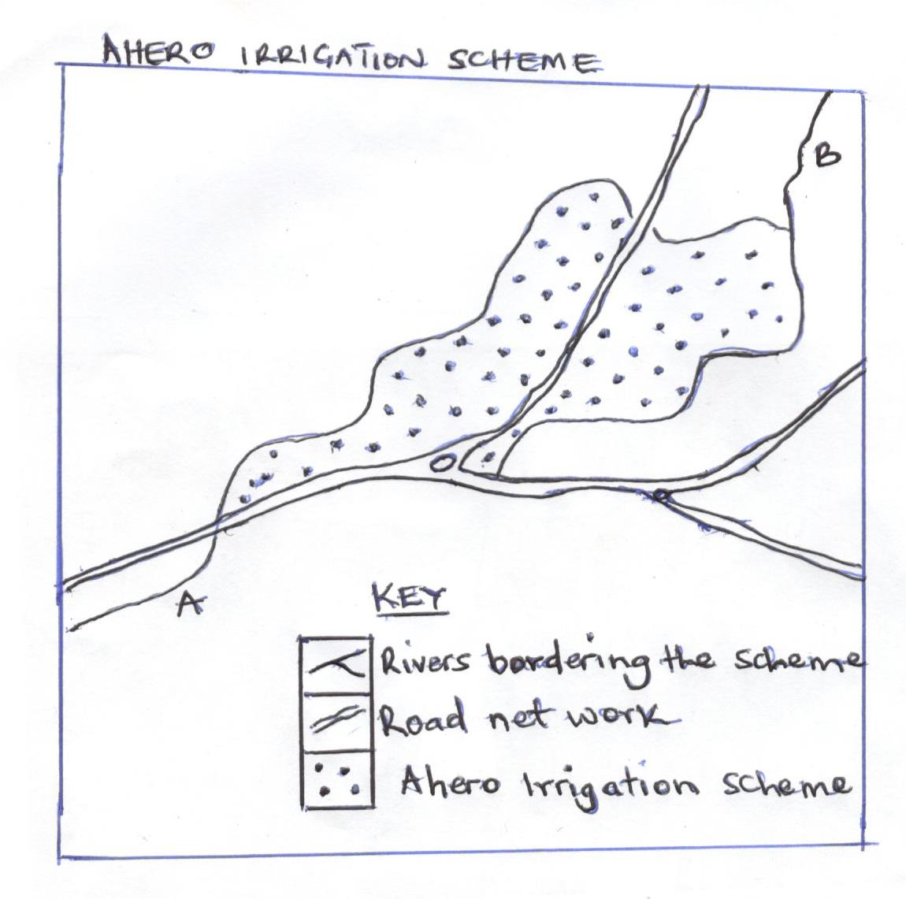

a) (i) Name the rivers marked A and B.

(ii) Apart from rice, mention two other crops grown on the scheme.

***(04 marks)***

b) Explain the benefits of Ahero Irrigation scheme to the people of Kenya. ***(06 marks)***

c) What are the problems hindering large scale irrigation farming in East Africa. ***(06 marks)***

d) Suggest the ways irrigation farming can be improved in East Africa. ***(04 marks)***

***End -***